**Aidan Brown**

**GEOG 501**

# Deliverable 1

Find the acreage of Aspen Stands:

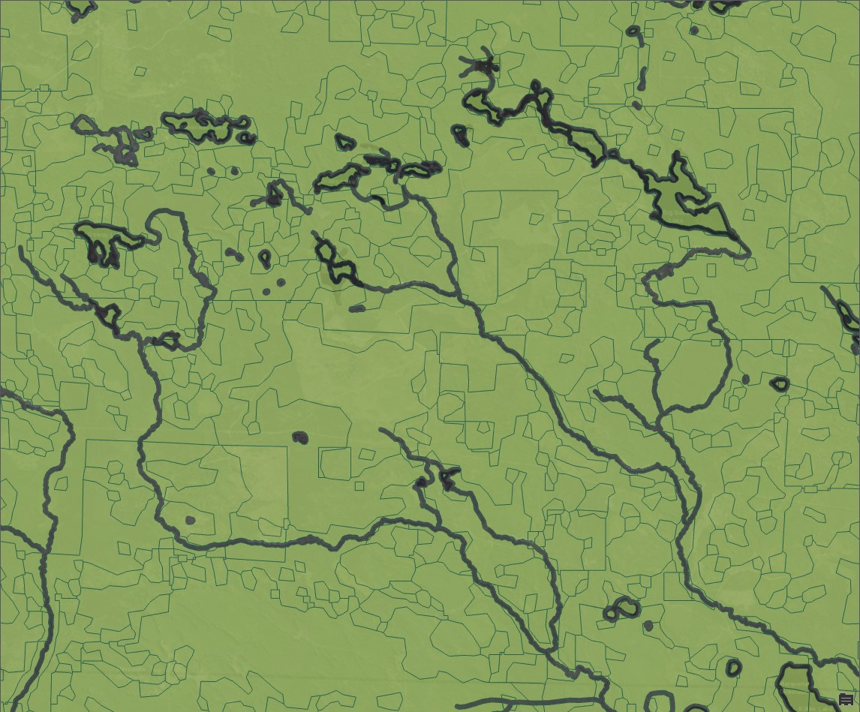

# Deliverable 2

Find the total acres that will be harvested:

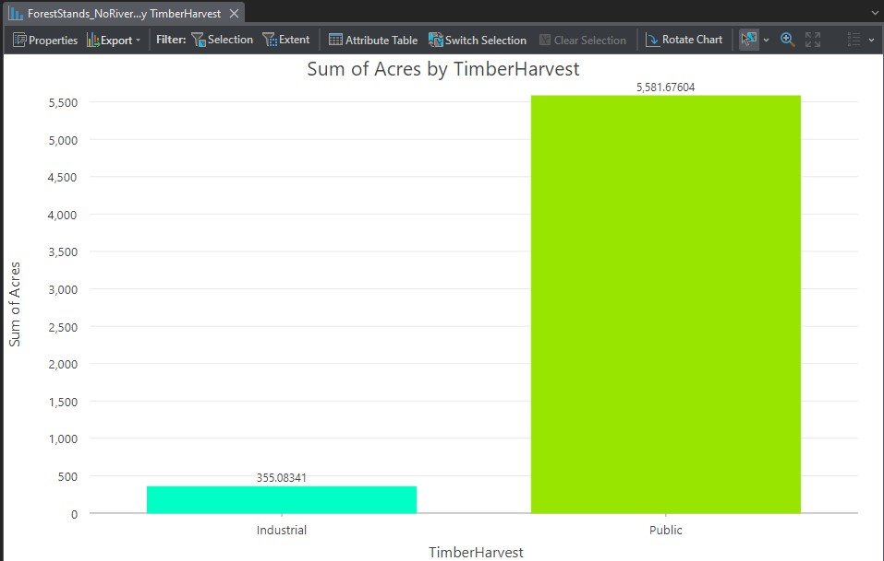

# Deliverable 3

Screen capture of the final statistics, similar to the image following step 6 of the section called Calculate volume:

